Video Game Sales Analysis
Title Page
- Dataset Name: Video Game Sales Analysis (Video Game Sales from Kaggle Dataset)
- Team Members: Zack Lee, Esther Law, Max Shuford
Introduction
- Dataset description: This dataset includes the year of the games released, the genre of the game, the name of the publisher, the name of the developer, as well as the sales of each game in North America, PAL region, and Japan as well as other sales and global sales.
Results
[Part 1: Zack Lee] for Student A
[Question 1]: Which attributes are most strongly correlated with global sales? (Correlation Matrix)
[Your Figure]

- Purpose:

- Methodology:

- Explain the graph (e.g. what is x axis, what is y axis),

- Harvest Highlights:

[Question 2]: Can we predict high-selling games using KNN?
[Your Figure]

[Your explanation: 1. Purpose, 2. Methodology, 3. Explain the graph (e.g. what is x axis, what is y axis), 4. Harvest Highlights.]

[Question 3]: How have global sales changed over the decades?
[Your Figure]

[Your explanation: 1. Purpose, 2. Methodology, 3. Explain the graph (e.g. what is x axis, what is y axis), 4. Harvest Highlights.]

[Part 2: Esther Law] for Student B
[Question 4]: Are certain publishers strongly associated with specific developers?
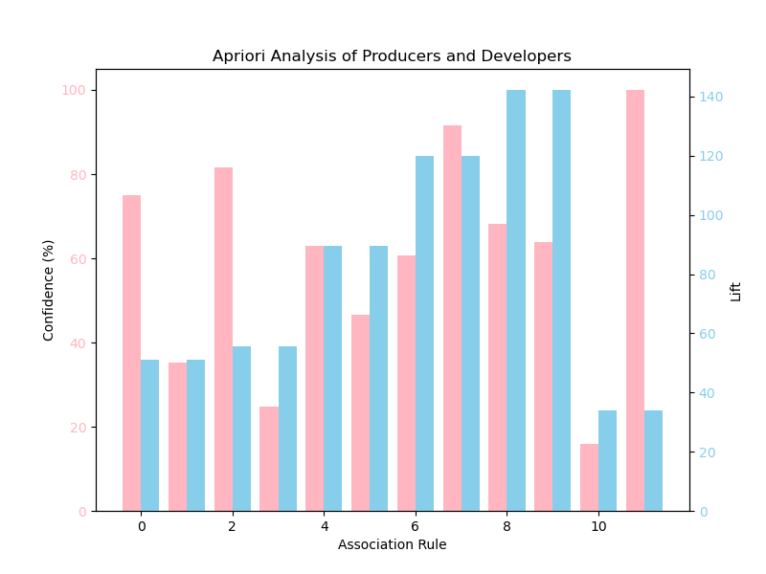

  - Purpose
The purpose of this graph is to visualize the confidence and lift values of association rules resulting from the Apriori analysis of video game Producers and Developers.
  - Methodology
To conduct this analysis, we first read the CSV file into a DataFrame and filter out the publisher and developer columns into a list. We then use TransactionEncoder to convert the list of publishers and developers to one-hot format. We then run the Apriori Algorithm to retrieve the total frequent itemsets. We then use these itemsets to generate the association rules. We then graph the information, converting confidence to their percentage values.
  - Explain the graph (e.g. what is x axis, what is y axis)
The x axis of the graph is each individual association rule and the y axis represents both the lift and confidence displayed side by side for comparison.
  - Harvest Highlights
********COMPLETE*************

[Question 5]: Which attributes have the highest correlation with critic scores?
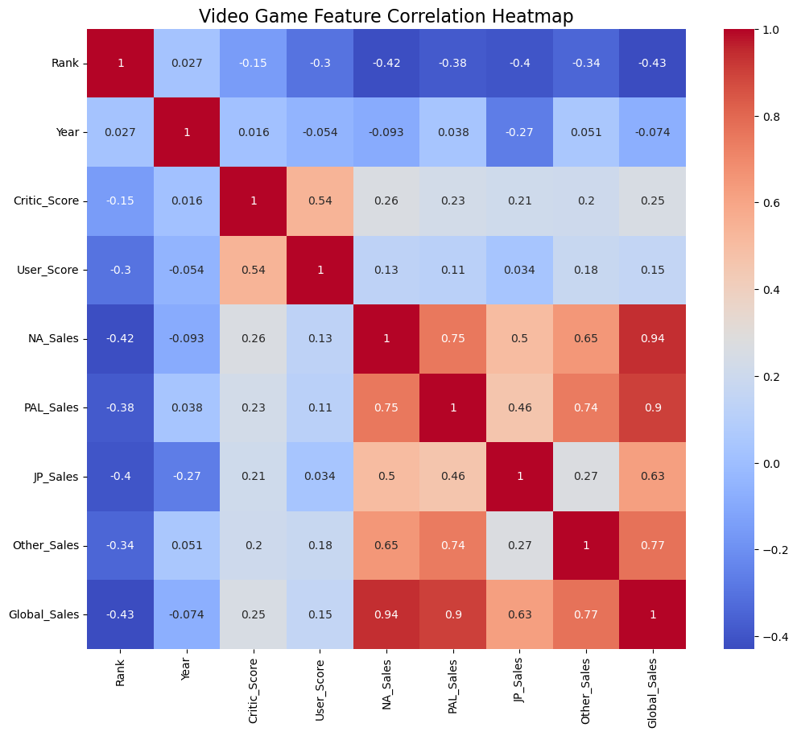

- Purpose
The purpose of this graph is to visualize what numeric features of the dataset have the highest correlation with good critic scores.
- Methodology
Filter the dataframe to only contain numeric values. Then use seaborn sns.heatmap() and df.corr() to visualize the correlation heatmap.
- Explain the graph (e.g. what is x axis, what is y axis)
This graph contains all of the data set’s numeric attributes and their correlations with each other as well as a key to represent the color correlation values.
- Harvest Highlights
We can see that user scores are highly correlated with critic scores, along with various attributes representing video game sales.
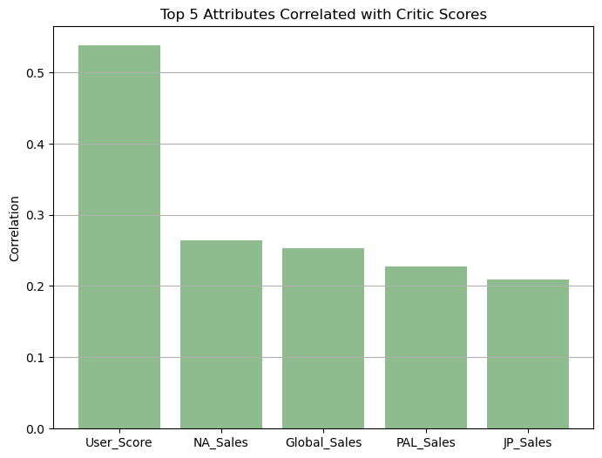

- Purpose
- Methodology
We first store the correlation in a dataframe in descending order and use that to find the top 5 attributes correlated with critic scores. We then use this information to create a bar graph visualizing these values.
- Explain the graph (e.g. what is x axis, what is y axis)
The x-axis of the graph represents the top 5 attributes correlated with critic scores. The y-axis represents the correlation values.
- Harvest Highlights
This shows that the attributes with the highest correlation with critic scores are user scores, NA sales, global sales, PAL sales, and JP sales.
[Question 6]: Can we predict whether a video game’s sales will be above or below average based on platform, developer, and year?
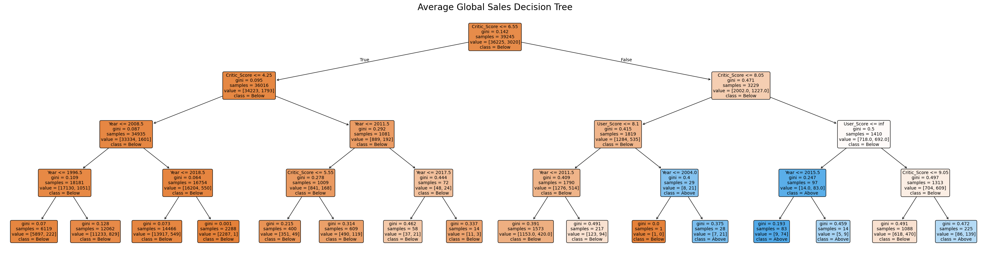
- Purpose
The purpose of this graph is to visualize if a video game’s global sales will be above or below average depending on its platform, developer, and year.
- Methodology
To do this, we first find the mean of global sales in the data set and make a new column containing the above/below average value of each video game. We then use LabelEncoder(), and train_test_split from sklearning to encode the data and split it into testing data and training data. After that, we use DecisionTreeClassifier with max_depth=4 to train the model. After the model is trained, we plot the tree to visualize the results.
- Explain the graph (e.g. what is x axis, what is y axis)
The graph shows four levels of decisions that can be made involving a video game’s platform, developer, and year. Based on these decisions, the tree displays whether or not a game’s global sales will be above or below average.
- Harvest Highlights
The decision tree shows that video games with higher critic and user scores are more likely to have above average global sales.

[Part 3: Max Shuford] for Student C
[Question 7]: Based on Rank and Regional Sales, can we determine a meaningful cluster of titles?
[Your Figure]

[Your explanation: 1. Purpose, 2. Methodology, 3. Explain the graph (e.g. what is x axis, what is y axis), 4. Harvest Highlights.]

[Question 8]: Can we predict a game's ranking based on its global sales?
[Your Figure]

[Your explanation: 1. Purpose, 2. Methodology, 3. Explain the graph (e.g. what is x axis, what is y axis), 4. Harvest Highlights.]

[Question 9]: What do the trends in game sales each year based on genre show?
[Your Figure]

[Your explanation: 1. Purpose, 2. Methodology, 3. Explain the graph (e.g. what is x axis, what is y axis), 4. Harvest Highlights.]

Overview
[Summarize at least three findings that you feel are most worth reporting.]
Contributions
[Student A, describe your responsibility in this project with details, mention what the methodology you use, what the big challenge you meet.]

[Student B, describe your responsibility in this project with details, mention what the methodology you use, what the big challenge you meet.]

[Student C, describe your responsibility in this project with details, mention what the methodology you use, what the big challenge you meet.]

